Project Name: **Netflix**

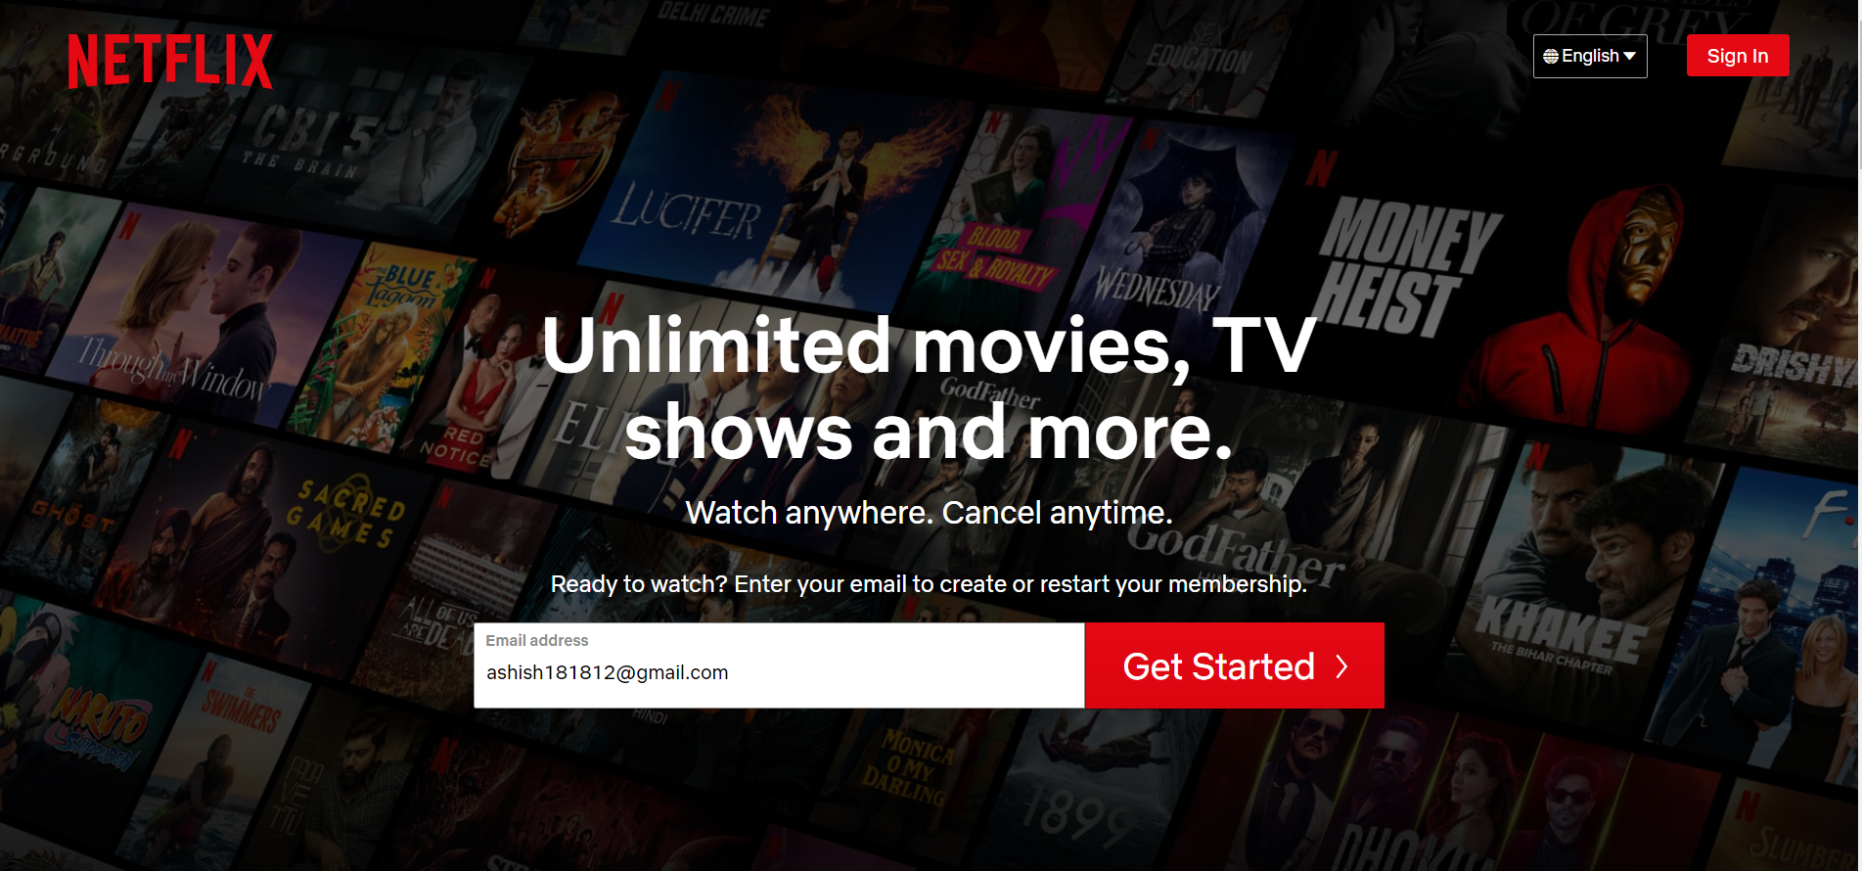

Overview:

Netflix is one of the world's leading entertainment services with 223 million paid memberships in over 190 countries enjoying TV series, documentaries, feature films and mobile games across a wide variety of genres and languages. Members can play, pause and resume to watch, as much as they want, anytime, anywhere, and can change their plans at any time.

Goals:

1. Login page

2. Subscription page

3. Payment page

4. Streaming page

5. Login and logout page

Technologies used in Netflix

Front-End:

1. Html

2. Css

3. Bootstrap

4. React

Dynamic:

1. Javascript

2. Login and Logout (oauth and jwt)

Database:

1. Mongodb

Compilers:

1. Visual studio code

2. Git bash

3. Git hub

4. Node js.